**File:** **Veselina_Kolova_8_65630e.rb**

Task:

Develop a program named FirstName_LastName_ClassNumber_65630e.rb

1. you are given an argument for a folder with files;

1.1 if there are other arguments they should be discarded

2. file names in this folder are in the form First_Last_digits.rb;

3. find all the students that have 5 letters in their second name;

4. Sort the result by First name DESC.

5. Produce a result in CSV format named result.csv:

FirstName1,LastName1

FirstName2,LastName2

...

FirstNameN,LastNameN

Code:

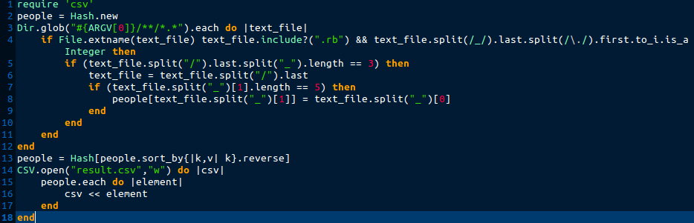

Errors:

* In line 4: syntax error, unexpected tIDENTIFIER, expecting keyword_then or ';' or '\n'

le.extname(text_file) text_file.include?(".rb") && text_file

* Check for files format is missing
* In line 4 bad condition
* In line 5 bad condition
* CSV is sorted by first name instead of last name

New code:

